I SEMESTER

COMPUTER FUNDAMENTALS AND MS OFFICE

UNIT-I
Introduction to computers, characteristics and limitations of computer, Block diagram of computer, types of computers, uses of computers, computer generations. Number systems:binary,hexaand octal numbering system

UNIT-II
Input and output devices: Keyboard and mouse,inputting data in other ways, Types of Software:system software,Application software,commercial,open source,domain and free ware software , Memories: primary,secondary and cache memory.windows basics: desk top,start menu,icons.

UNIT III
System Software, Compilers, assemblers, loaders, Operating Systems fundamentals, Introduction to Algorithms and Programming Languages

PROGRAMMING USING C

UNIT - I
Introduction to Algorithms and Programming Languages: Algorithm – Key features of Algorithms – examples of Algorithms – Flow Charts – Pseudo code – Programming Languages
– Generation of Programming Languages – Structured Programming Language.
Introduction to C: Introduction – Structure of C Program – Writing the first C Program – File used in C Program – Compiling and Executing C Programs – Using Comments – Keywords – Identifiers – Basic Data Types in C – Variables – Constants – I/O Statements in C- Operators in C- Programming Examples – Type Conversion and Type Casting.

UNIT - II
Decision Control and Looping Statements: Introduction to Decision Control Statements – Conditional Branching Statements – Iterative Statements – Nested Loops – Break and Continue Statement – Goto Statement.
Functions: Introduction – using functions – Function declaration/ prototype – Function definition – function call – return statement – Passing parameters – Scope of variables – Storage Classes – Recursive functions – Type of recursion – Towers of Hanoi.
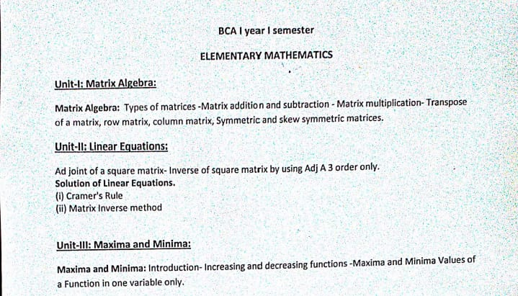

III SEMESTER

OBJECT ORIENTED PROGRAMMING USING JAVA
UNIT-1

FUNDAMENTALS OF OBJECT – ORIENTED PROGRAMMING: Introduction, Object Oriented paradigm, Basic Concepts of OOP, Benefits of OOP, Applications of OOP, Java features: OVERVIEW OF JAVA LANGUAGE: Introduction, Simple Java program structure, Java tokens, Java Statements, Implementing a Java Program, Java Virtual Machine, Command line arguments. CONSTANTS, VARIABLES & DATA TYPES: Introduction, Constants, Variables, Data Types, Declaration of Variables, Giving Value to Variables, Scope of variables, Symbolic Constants, Type casting, Getting Value of Variables, Standard Default values; OPERATORS & EXPRESSIONS.

UNIT-II

DECISION MAKING & BRANCHING: Introduction, Decision making with if statement, Simple if statement, if. Else statement, Nesting of if. else statements, the else if ladder, the
switch statement, the conditional operator. LOOPING: Introduction, The While statement, the do-while statement, the for statement, Jumps in loops.

CLASSES, OBJECTS & METHODS: Introduction, Defining a class, Adding variables, Adding methods, Creating objects, Accessing class members, Constructors, Method overloading, Static members, Nesting of methods;

UNIT-III

INHERITANCE: Extending a class, Overloading methods, Final variables and methods, Final classes, Abstract methods and classes;

ARRAYS, STRINGS AND VECTORS: Arrays, One-dimensional arrays, Creating an array, Two – dimensional arrays

DATABASE MANAGEMENT SYSTEMS

Unit-1

Database Systems: Introducing the database and DBMS, Files and File Systems, Problems with
File System and advantages of Database Management systems.

Data Models: The importance of Data models, Data Model Basic Building Blocks, Business
Rules, The evaluation of Data Models, Degree of Data Abstraction.

Unit-II

The Relational Database Model: A logical view of Data, Keys, Integrity Rules, Relational Set Operators, The Data Dictionary and the system catalog, Relationships with in the Relational Database, Data Redundancy revisited, Indexes, Codd’s relational database rules.

Entity Relationship Model: The ER Model, Developing ER Diagram,

Unit-III

Normalization of database tables: Database Tables and Normalization, The need for
Normalization, The Normal forms of BCNF

ACCOUNTS & FINANCIAL MANAGEMENT
Unit-I :
Introduction: Meaning objectives, process, limitations and basic terms of Accounting; Generally accepted Accounting principles; Journalizing, Posting and preparation of trial balance. Rectification of errors.
Unit-II
Capital and revenue items; Reserves and Provisions; Depreciation : Meaning, causes, accounting procedure methods of computing depreciation- straight line method and Final accounts with adjustments;
Unit-III
Nature of Financial Management: Scope of Finance, Finance functions, Financial Manager’s role, Financial goals.

V SEMESTER
SOFTWARE ENGINEERING

UNIT I

INTRODUCTION: Software Engineering Process paradigms - Project management - Process and Project Metrics – software estimation - Empirical estimation models – Planning.

UNIT II

REQUIREMENTS ANALYSIS: Requirement Engineering Processes – Feasibility Study –
Problem of Requirements – Software Requirement Analysis – Analysis Concepts and Principles
– Analysis Process – Analysis Model

UNIT III

SOFTWARE DESIGN: Software design - Abstraction - Modularity - Software Architecture - Effective modular design - Cohesion and Coupling

NETWORK SECURITY

UNIT – I

INTRODUCTION: OSI Security Architecture - Classical Encryption techniques - Cipher
Principles - Data Encryption Standard - Block Cipher Design Principles and Modes of Operation.

UNIT - II

PUBLIC KEY CRYPTOGRAPHY: Key Management - Diffie-Hellman key Exchange - Elliptic Curve Architecture and Cryptography - Introduction to Number Theory - Confidentiality using Symmetric Encryption - Public Key Cryptography and RSA.

UNIT – III

AUTHENTICATION AND HASH FUNCTION: Authentication requirements - Authentication functions.

OBJECT ORIENTED ANALYSIS & DESIGN

UNIT I
Introduction to OOAD – What is OOAD? – What is UML? What are the United process(UP) phases - Case study – the NextGen POS system, Inception -Use case Modeling - Relating Use cases – include, extend and generalization.

UNIT II
Elaboration - Domain Models - Finding conceptual classes and description classes – Associations – Attributes – Domain model refinement – Finding conceptual class hierarchies- AggregationandComposition.
UNIT III
UML activity diagrams and modeling – USE CASE diagram

Computer Networks

UNIT I
Network architecture – layers – Physical links – Channel access on links – Hybrid multiple access techniques - Issues in the data link layer - Framing – Error correction and detection – Link-level Flow Control.
UNIT II
Medium access – CSMA – Ethernet – Token ring – FDDI - Wireless LAN – Bridges and witches
UNIT III
Circuit switching vs. packet switching / Packet switched networks – IP – ARP – RARP –DHCP – ICMP – Queueing discipline

Android Basics

UNIT-I

What is Android, Android Tools, Your First Android Application, Anatomy of Android Application, Workspaces, Editors in Eclipse, Eclipse Perspective, Refactoring
UNIT-II

Creating Android Emulator, Creating Snapshot, SD Card Emulation, Sending SMS Messages to the Emulator , Transferring Files into and out of the Emulator ,Resetting the Emulator

UNIT-III

Activity, Linking Activity using Intent, Fragments, Calling Build-In Application using Intent,
Notifications

